This is Kristjan Qullamaggie.

He's a swing trader, who turned $9,100 into over $80,000,000 from 2013 to 2021.

In 2021, he was featured as the 15th highest income earner in Sweden.

Here’s Kristjan's story:

1) Returns

There's many stories online, of traders with large returns.

But in most cases, it's hard to find validation for those stories.

I found this article, where Kristjan was listed as the 15th top earner in 2021, in Sweden.

Link in sources at the end of the thread.

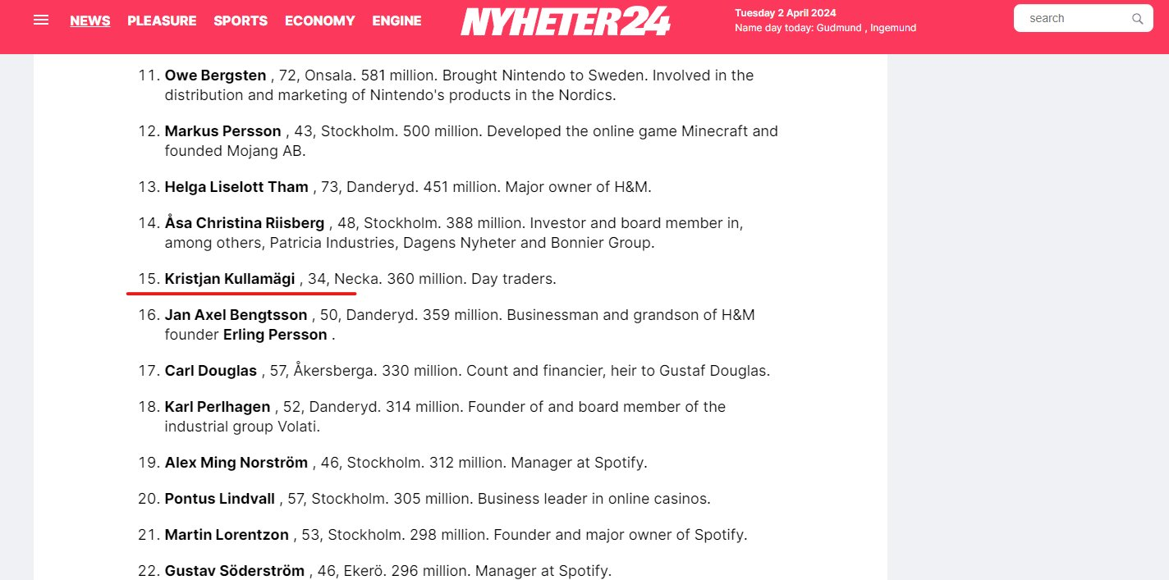

2) Who is Kristjan Qullamaggie

Kristjan is a self-funded trader from Sweden.

He's mostly known for making 10's of millions of dollars as a swing trader.

He started as a day trader back in 2011, at the age of 23 years old.

He mentions that he blew his account 3 or 4 times, for 2 years, before becoming profitable.

Despite his early failures, as most aspiring traders experience, he continued to improve.

Gradually he went from a losing trader, to breakeven, and 2013 was his first profitable year.

3) Position Size & Risk

Kristjan says that one shouldn't hold more than 30% of account size in a single position overnight.

And the risk per position should be 0.25%-1.5%

On a $10,000 account, a single position shouldn't exceed $30,000, and the risk per trade would be $150.

4) The Breakout Trade

Let's systematize his strategy:

1) Initial driver move of >30% in the last 12 weeks
2) Sideways consolidation of 2-8 weeks
3) Consolidation average > 10/20/50 SMA
4) Enter trade on the breakout
5) Stop loss at low of breakout day
6) Stop loss < 1*ATR

5) Exit Rules

Let's also systematize his exit rules:

1) Selling 1/3 or 1/5 of the position within 3-5 days after entry
2) Move the stop to breakeven
3) The remaining position has a trailing stop loss using the 10/20 moving average.
4) Exit if price closes below the trail.

6) Trade Examples

Here we have an example of a trade, that fit the parameters of Kristjan's strategy.

It can be summarized to taking positions on breakouts, of strong uptrends.

During a great market regime, this strategy will shine.

7) Philosophy

Kristjan sees trading as a numbers game.

The strategy itself is not ground-breaking.

Breakout trading has been documented for decades.

His focus is in being in the largest trends, taking a lot of bets and keeping the losses small.

8) Conclusion

Kristjan's story is quite interesting.

Even though I couldn't find what his returns are after 2021, his principles are solid.

Managing exposure, risk, and being exposed to trends, is the core idea behind his message.

Hope you've enjoyed it.

Sources:

1) youtube.com/watch?v=WswZwm…
2) qullamaggie.com/about/
3) nyheter24.se/nyheter/ekonom…
4)
https://youtu.be/K0F73Sq90j0?si=kPZ7GsV0PCHtreS6

https://youtu.be/WswZwmr2ebU?si=jSuj6ZClkLbXRyNh

